**Project Synopsis**

**Airline Reservations**

Objective/ Vision

Echo Flights is an airline reservation website where admin can add, view, delete, update Flights and user can book a flight, as well as check availability, view flights, view transition history with Echo, & give Feedback.

Users of the System

1. Admin
2. User
3. Guest

Functional Requirements - Modules

1. **Admin**
   1. Add Flight
   2. Add Airport
   3. Remove Flight
   4. Remove Airport
   5. Update Flight
   6. Update Airport
   7. Flight information
2. **User**
   1. Search Flights
   2. Check Seat Availability
   3. Seat Booking
   4. Transaction History
3. **Guest**
   1. Search Flights
   2. Check Seat Availability

Technologies/Tools to be used Developed By:

1. Angular Vikas Dhiman(Team Lead)
2. JDK 8 and Above Prajjwal Jaiswal
3. Visual Studio code Prateek Sharma
4. Spring Tool Suite 4 Yogesh Bora
5. Postman
6. NPM
7. MySQL for database

Screenshots

Home Page

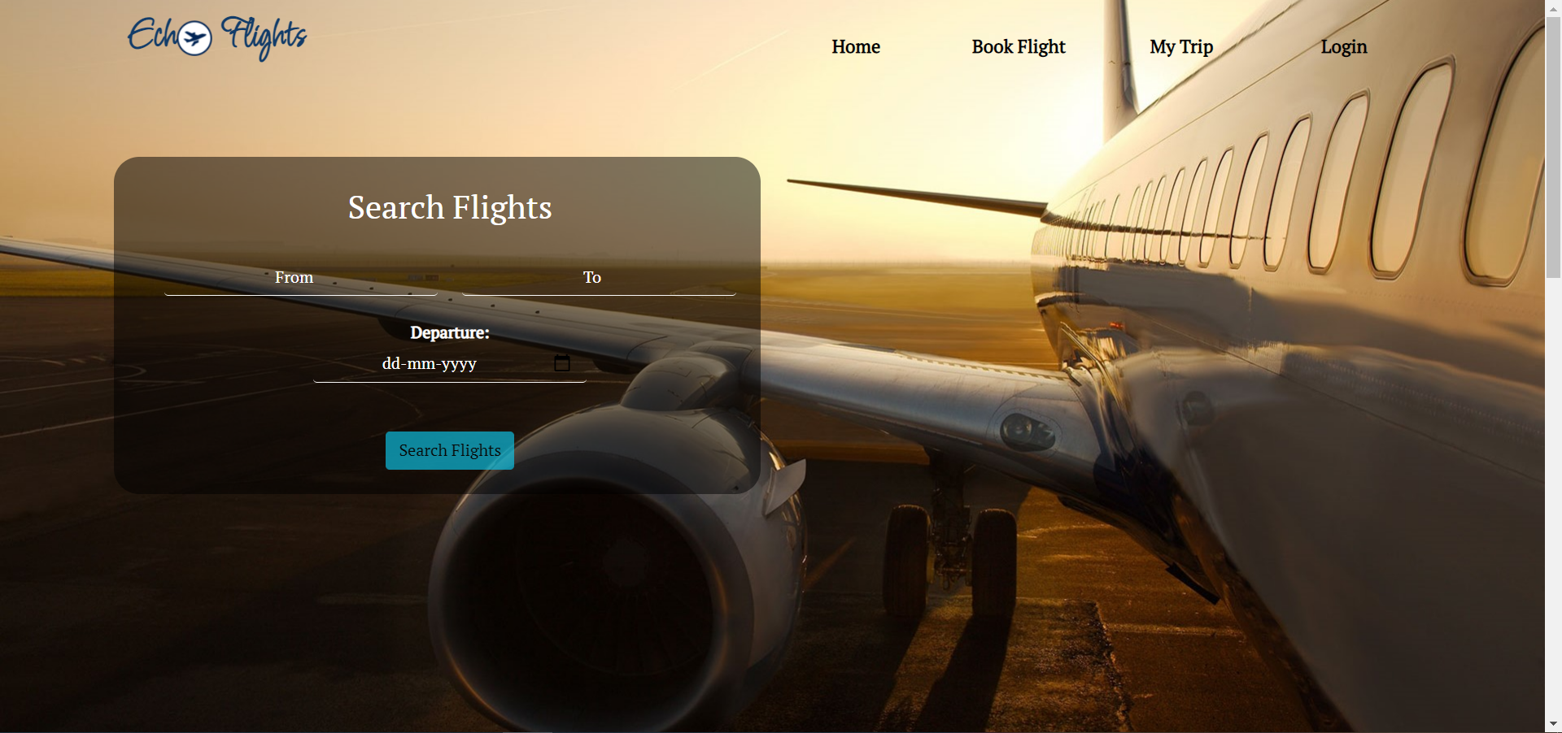

Login Page

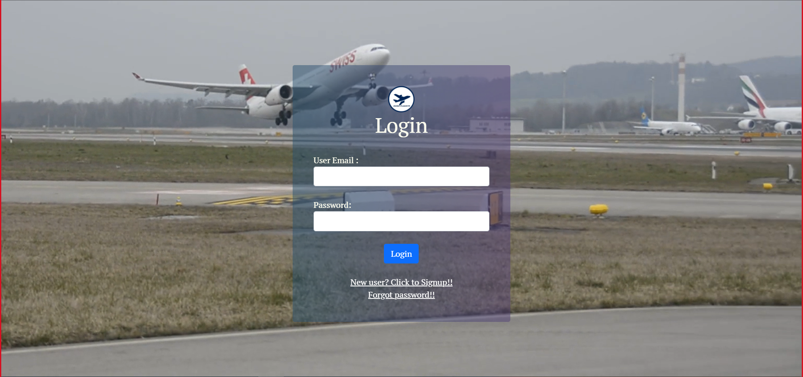

Sign-up Page

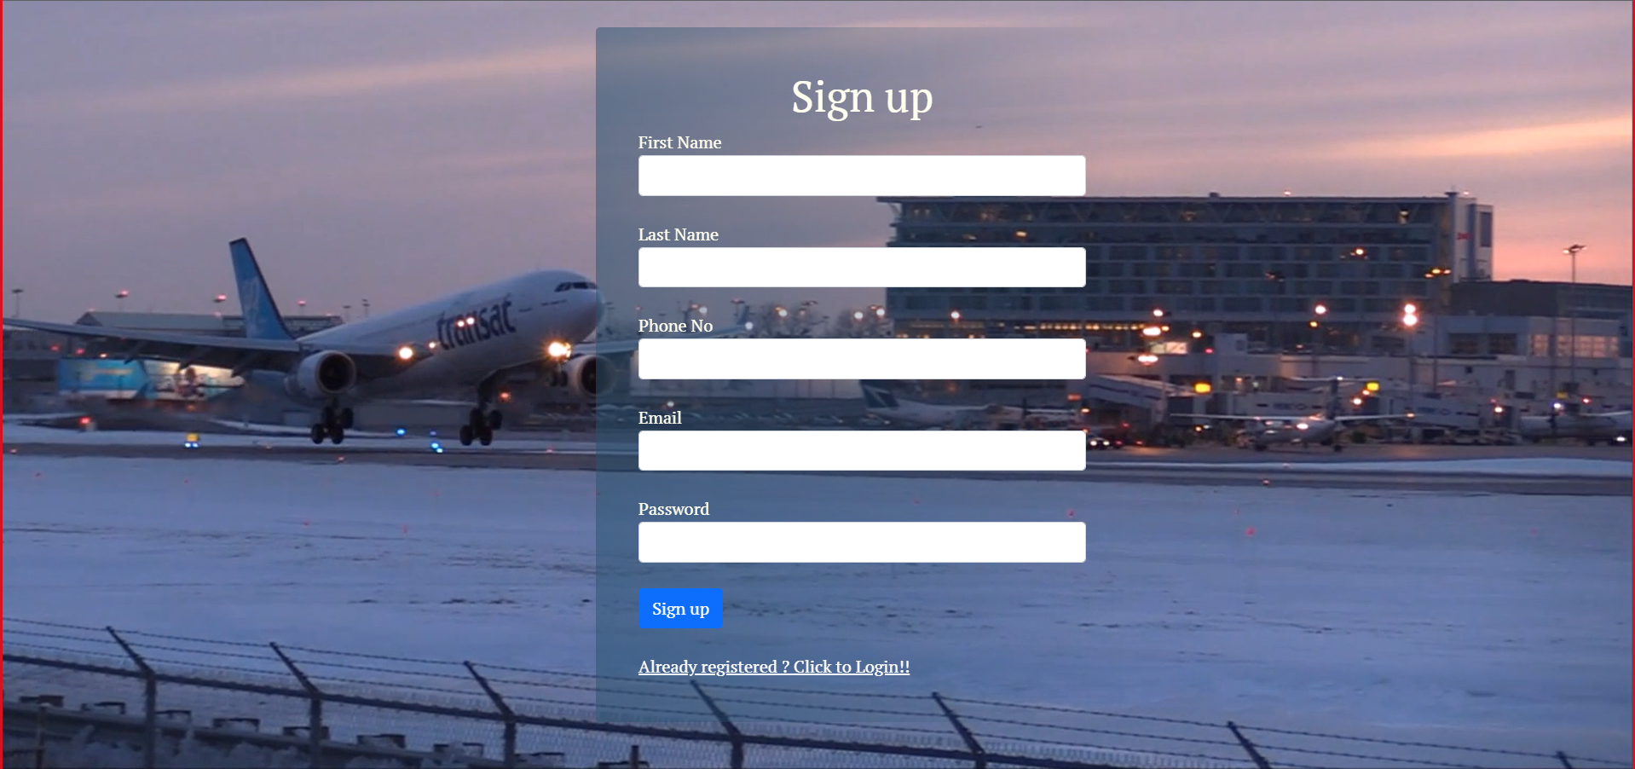

Reset Password

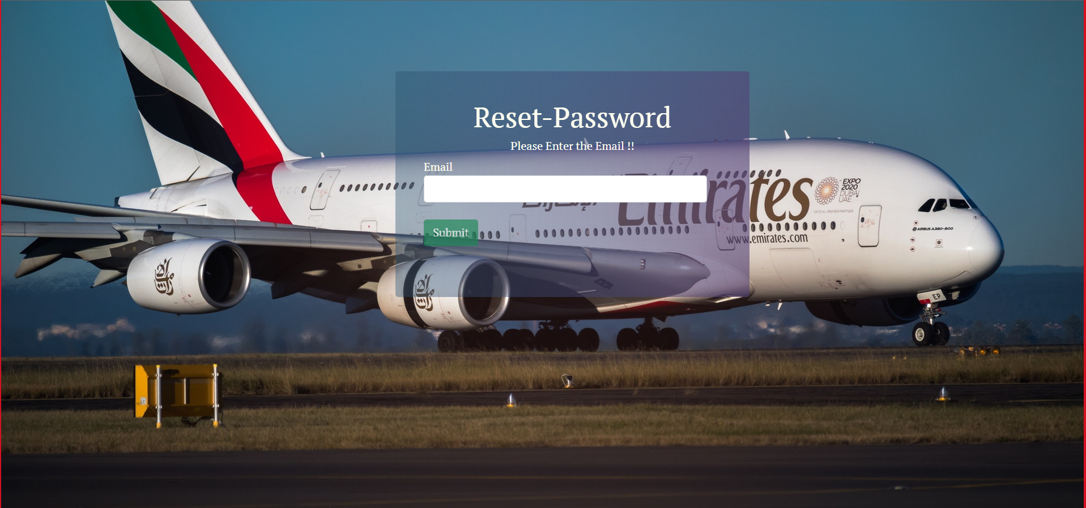

Home Page (Admin)

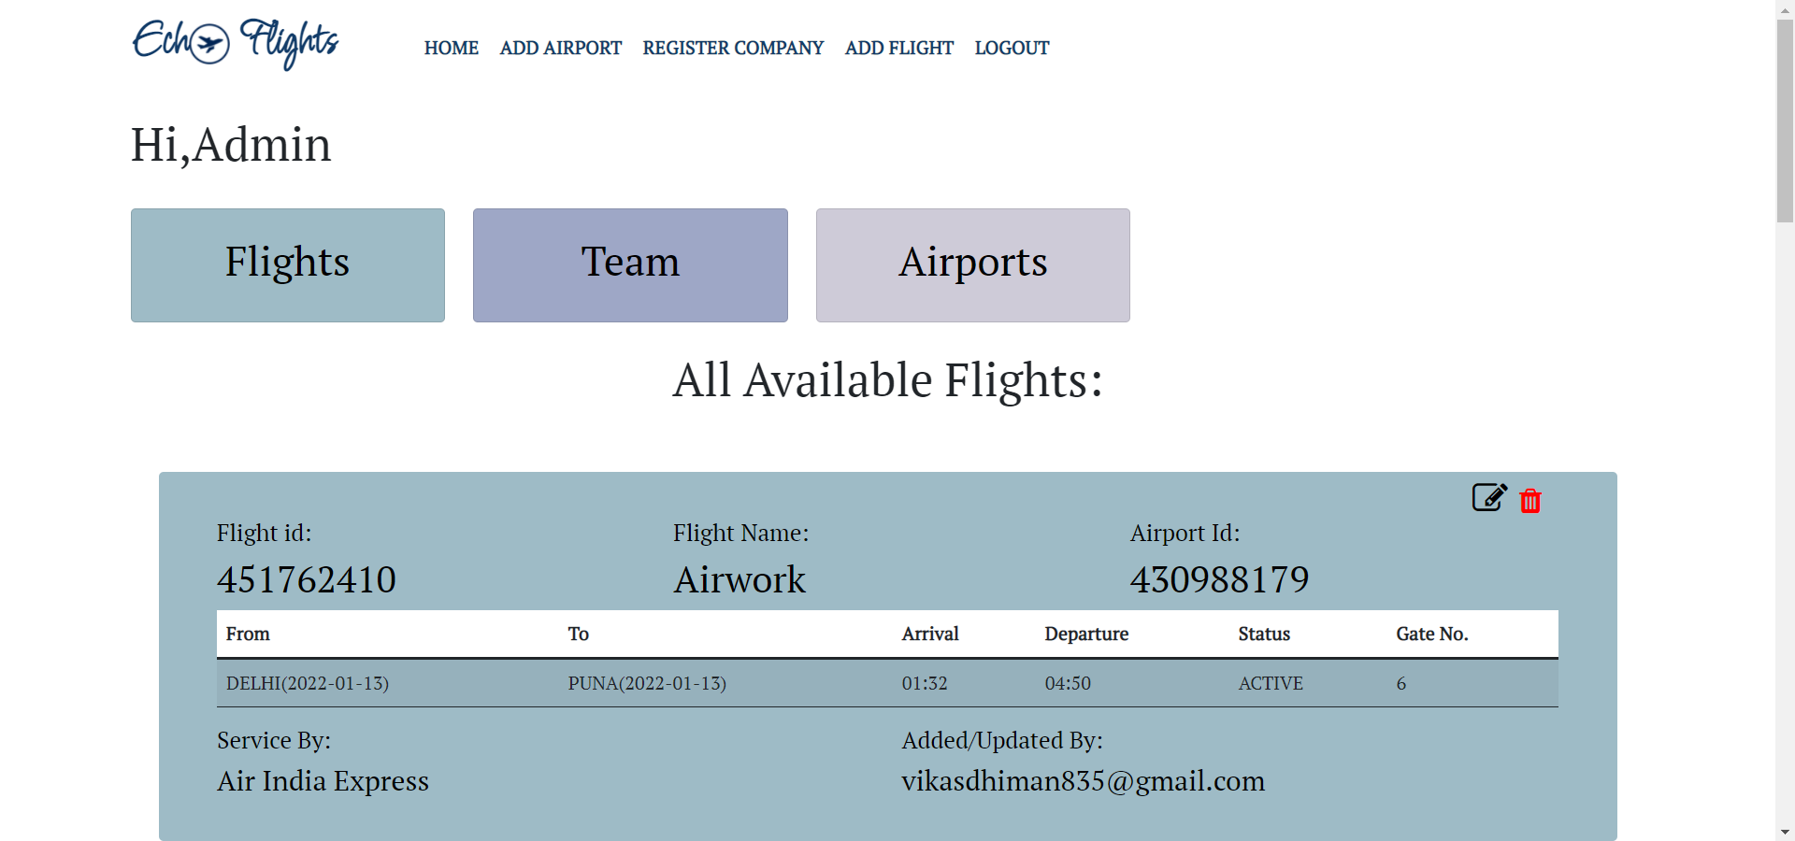

Add Flight

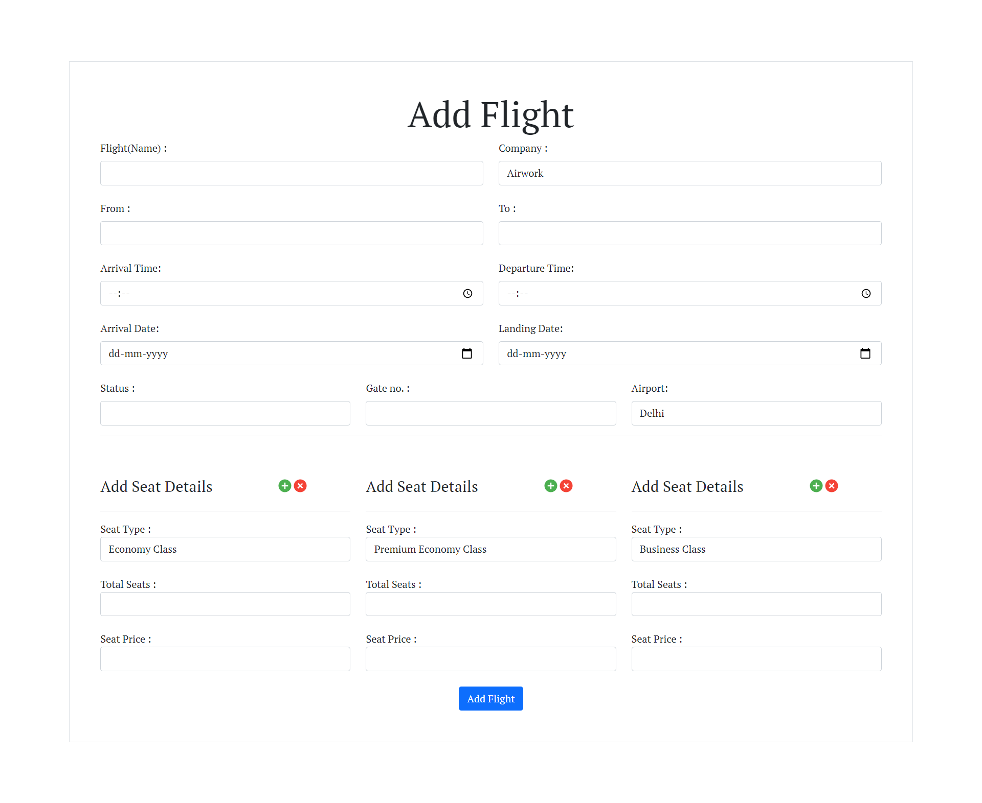

User Home Page

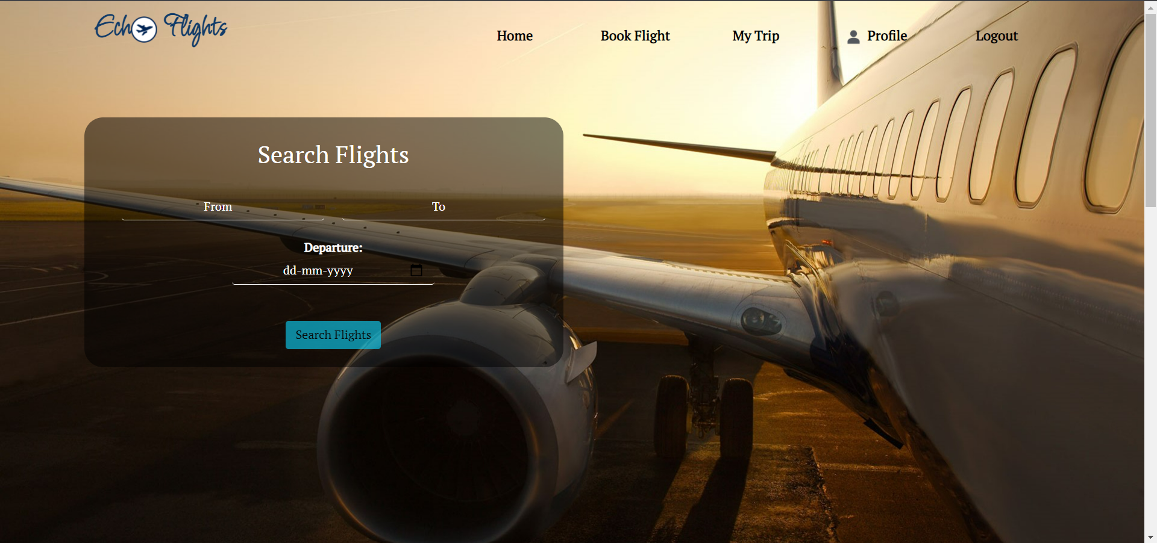

Profile Page

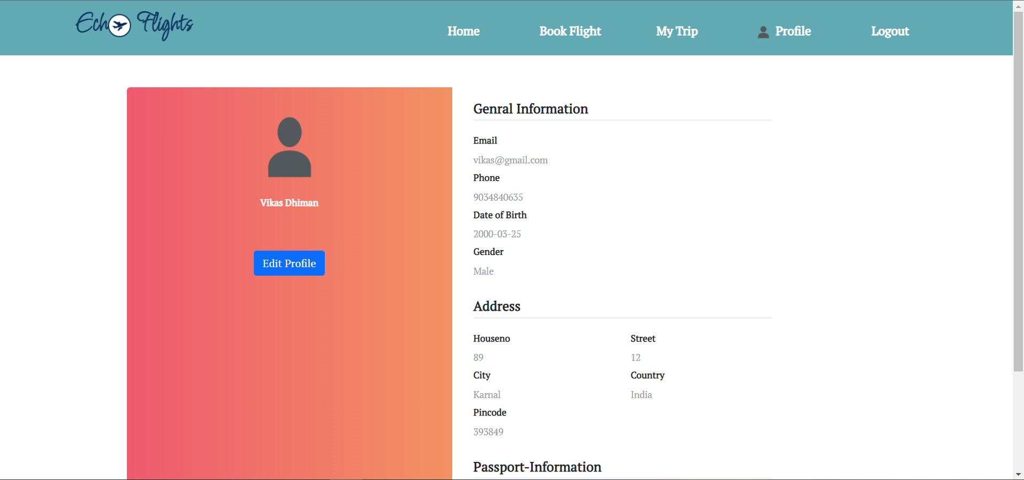

Search Flight

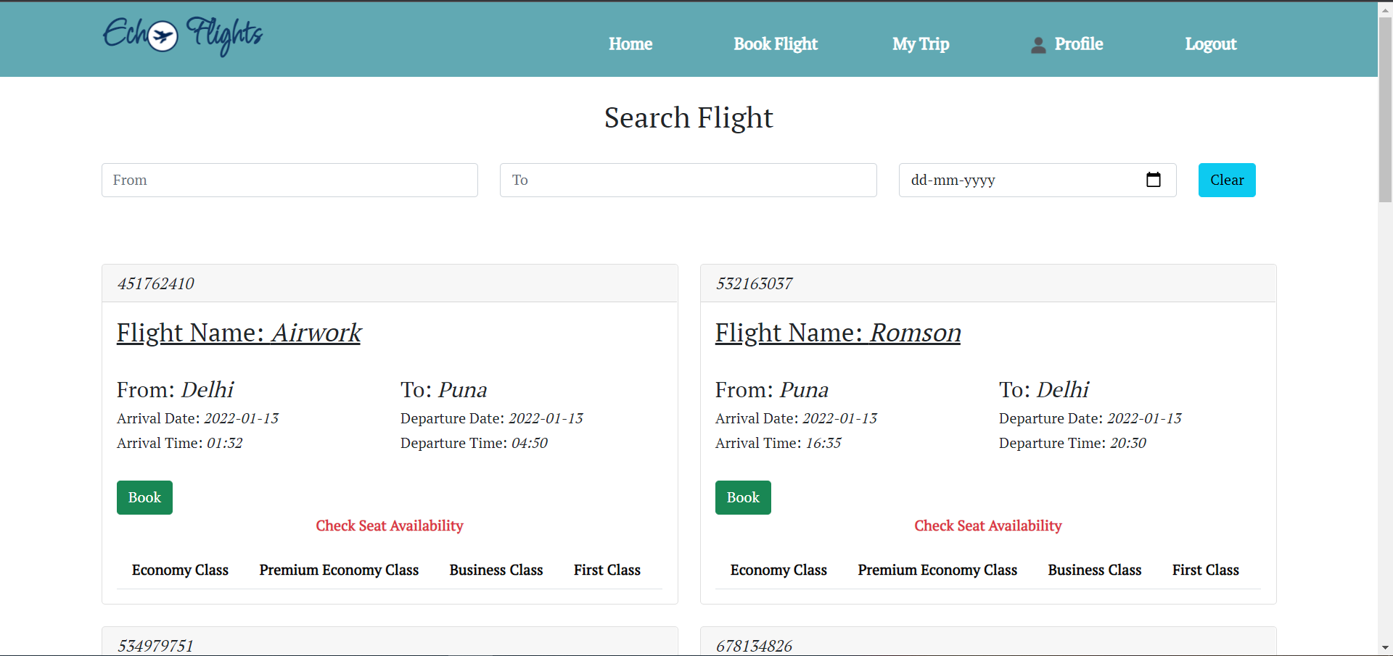

Add Passenger

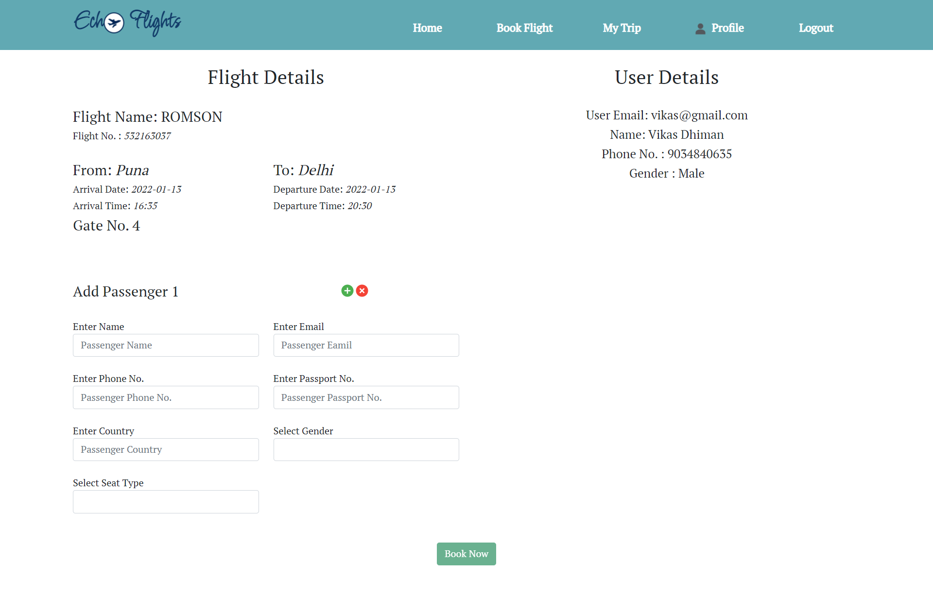

Confirmation Page

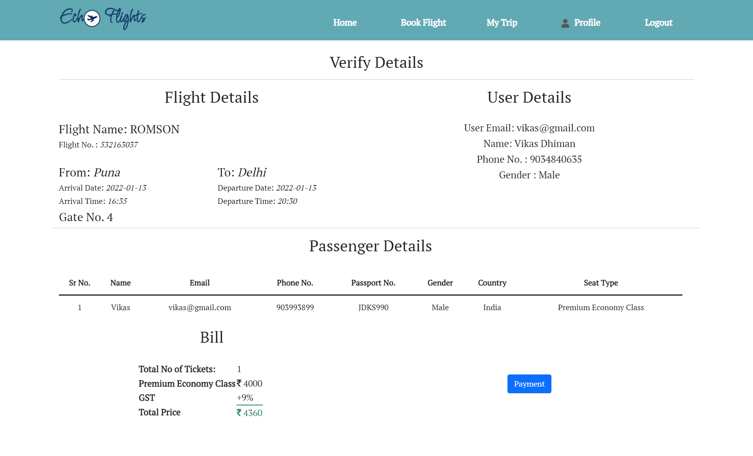

Payment Page

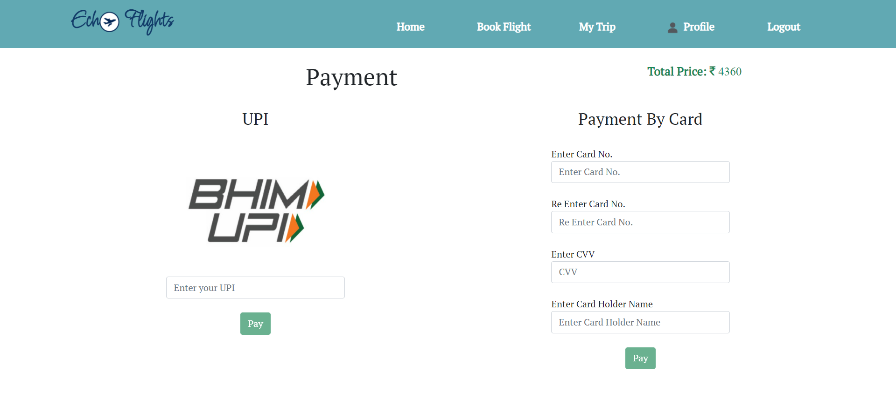

Ticket Booking Page: Success

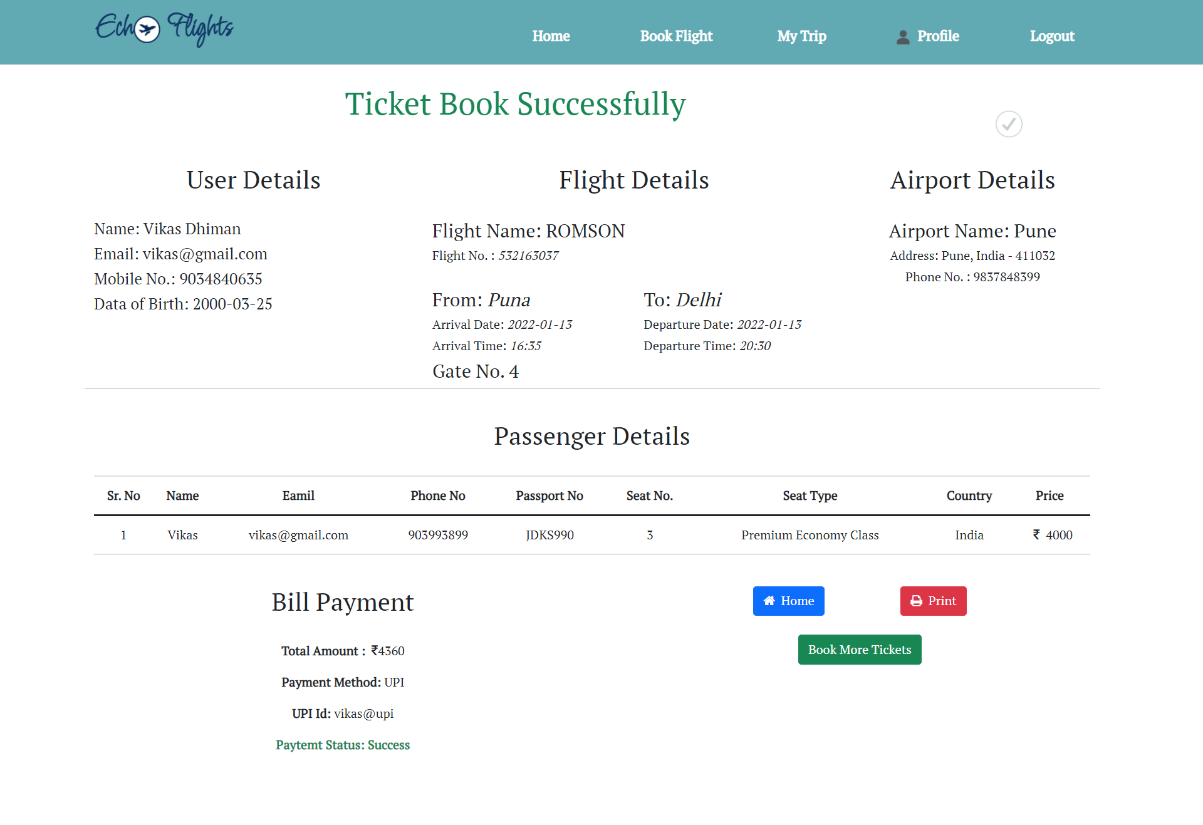

Booking History

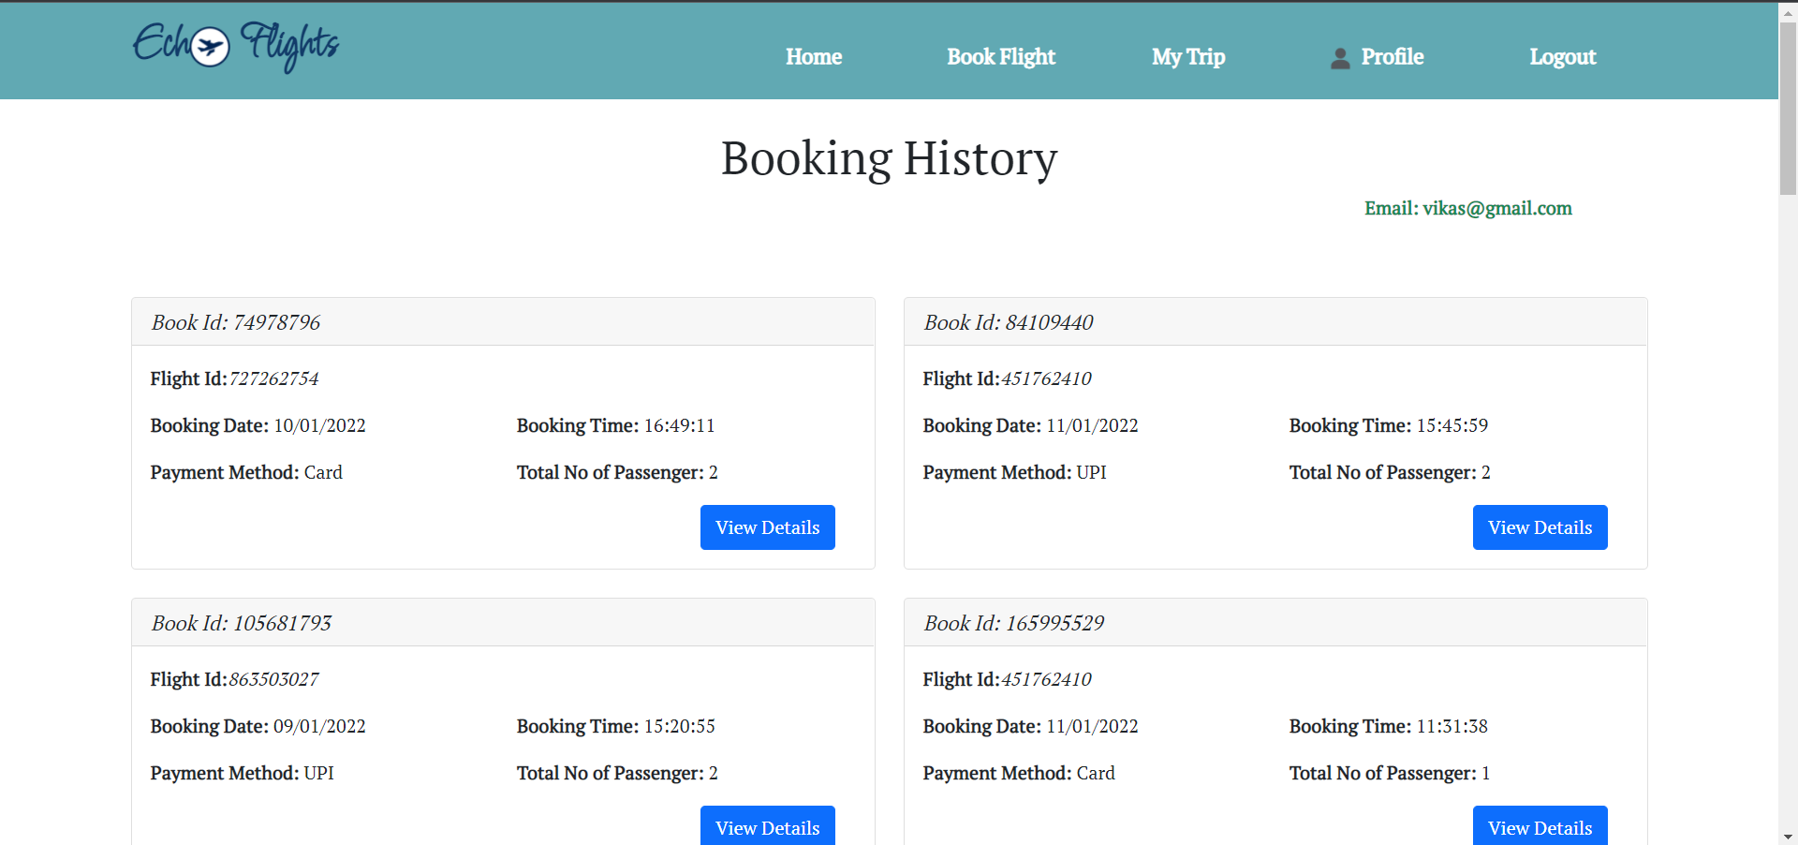

Ticket Details

